Lab # 4
string class

OBJECTive:

To Study String class and String Buffer.

THEORY:

4.1 STRINGS
In JAVA, Ordinary strings are objects of the class String. The String class is a standard class, and it is specifically designed for creating and processing strings.
The Java platform provides the String class to create and manipulate strings.

Creating String Objects:
Just to make sure there is no confusion in your mind, a String variable is simply a variable that stores a reference to an object of the class String. You declare a String variable in much the same way as you define a variable of one of the basic types. You can also initialize it in the declaration, which is generally a good idea:

This declares the variable myString as type String and initializes it with a reference to a String object encapsulating the string “My inaugural string”. You can store a reference to another string in a String variable, once you have declared it, by using an assignment. For example, you can change the value of the String variable myString to the statement:
The effect of this is illustrated in Figure
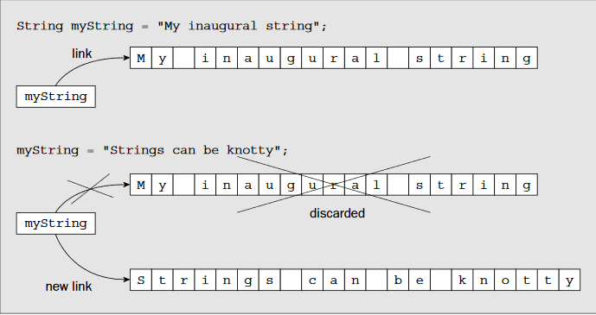

You should also keep in mind that characters in a string are Unicode characters, so each one typically occupies 2 bytes, with the possibility that they can be 4 bytes if you are using characters represented surrogates.

Of course, you can declare a variable of type String in a method without initializing it:

Arrays of Strings:

You can create arrays of strings. You declare an array of String objects with the same mechanism that you used to declare arrays of elements for the basic types. You just use the type String in the declaration. For example, to declare an array of five String objects, you could use the statement

It should now be apparent that the argument to the method main()is an array of String objects because the definition of the method always looks like this:

You could also declare an array of String objects where the initial values determine the size of the array:

This array will have 7 elements because there are 7 initializing string literals between the braces.

Of course, as with arrays storing elements of primitive types, you can create arrays of strings with any number of dimensions. You can try out arrays of strings with a small example.

Let’s create a program to generate your lucky star for the day:

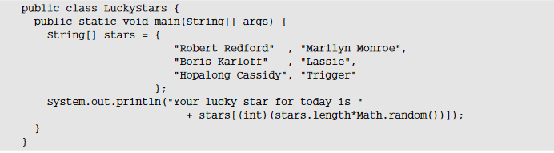

Output:
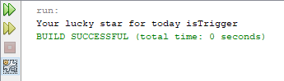

Operations on Strings:

There are many kinds of operations that can be performed on strings, but let’s start with one you have used already, joining two or more strings together to form a new, combined string. This is often called string concatenation.
Joining Strings:

To join two String objects to form a new, single string you use the +operator, just as you have been doing with the argument to the println()method in the program examples thus far. The simplest use of this is to join two strings together:

This will join the two strings on the right of the assignment and store the result in the String variable myString. The +operation generates a completely new String object that is separate from the two original String objects that are the operands, and this new object is stored in myString. Of course, you also use the +operator for arithmetic addition, but if either of the operands for the +operator is a String object or literal, then the compiler will interpret the operation as string concatenation and will convert the operand that is not a String object to a string. Here’s an example of concatenation strings referenced by String variables:

If a String variable that you use as one of the operands to + contains null, then this will automatically be converted to the string “null”. So if the month variable contained null instead of a reference to the string “December”, the result of the concatenation with date would be the string “31st null”. Note that you can also use the +=operator to concatenate strings. For example:

String Methods:
Here are the list methods supported by String class:

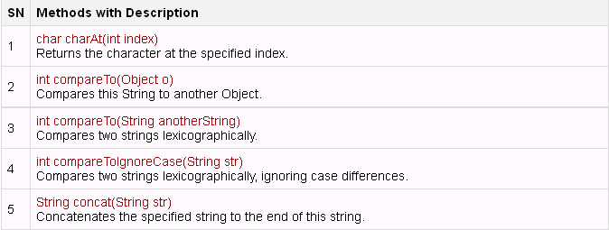

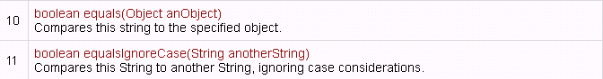

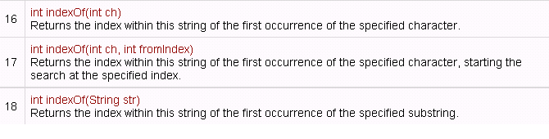

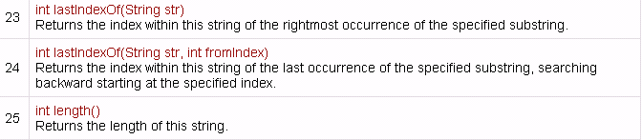

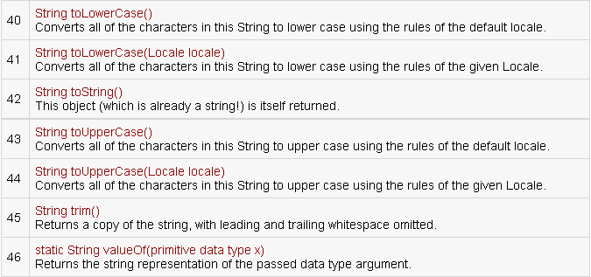

Program#1
This program uses different string classes.

public class StringClass{
public static void main (String[] args){

String s1 = new String("ABC");
String s2 = new String("ABC");
String s3 ="ABC";
String s4 ="ABC";
String s5 = new String("abc");

System.out.println("\t\t\ts1="+s1);
System.out.println("\t\t\ts2="+s2);
System.out.println("\t\t\ts3="+s3);
System.out.println("\t\t\ts4="+s4);
System.out.println("\t\t\ts5="+s5);

System.out.println("\n** == **");
System.out.println("\ns1==s2 -> "+(s1==s2));
System.out.println("s1==s3 -> "+(s1==s3));
System.out.println("s3==s4 -> "+(s3==s4));

//Equals
System.out.println("\n**Equals**");
System.out.println("s1.equals(s2) -> "+s1.equals(s2));
System.out.println("s1.equals(s5) -> "+s1.equals(s5));
System.out.println("XYZ".equals("XYZ"));

//Equals Ignore Case
System.out.println("\n**Equals Ignore Case**");
System.out.println(s1.equalsIgnoreCase(s5));
System.out.println("XYZ".equalsIgnoreCase("xyz"));

//Starts With
System.out.println("\n**Starts With**");
System.out.println(s1.startsWith("A"));

//Ends With
System.out.println("\n**Ends With**");
System.out.println(s1.endsWith("C"));
System.out.println("SSUET Karachi".endsWith("i"));

//Compare To
System.out.println("\n**Compare To**");
System.out.println(s1.compareTo(s2));

//Character At
System.out.println("\n**Character At**");
System.out.println(s1.charAt(0));

//Length
System.out.println("\n**Length**");
System.out.println(s1.length());

//To Lower Case
System.out.println("\n**To Lower Case**");
System.out.println(s1.toLowerCase());

//Index Of
System.out.println("\n**Index Of**");
System.out.println(s1.indexOf('A'));

//last Index Of
System.out.println("\n**last Index Of**");
System.out.println(s1.lastIndexOf('A'));

//Sub String
System.out.println("\n**Sub String**");
System.out.println(s1.substring(1,2));

//Replace
System.out.println("\n**Replace**");
System.out.println(s1.replace('A','Z'));

}
}

Output:
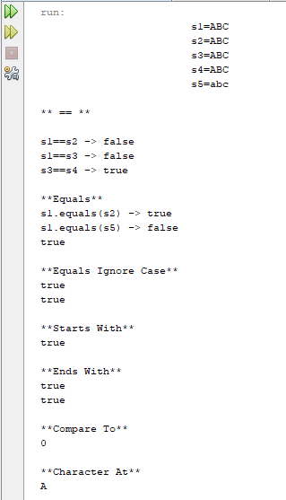

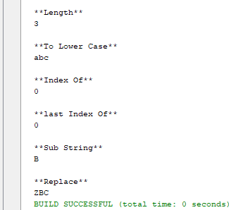

Note: The String class is immutable, so that once it is created a String object cannot be changed. If there is a necessity to make a lot of modifications to Strings of characters then you should use String Buffer & String Builder Classes.

4.2 STRING BUFFER

StringBuffer is a peer class of String that provides much of the functionality of strings. As you know, String represents fixed-length, immutable character sequences. In contrast, StringBuffer represents growable and writeable character sequences. StringBuffer may have characters and substrings inserted in the middle or appended to the end. StringBuffer will automatically grow to make room for such additions and often has more characters pre allocated than are actually needed, to allow room for growth.

StringBuffer Constructors:

StringBuffer defines these three constructors:

StringBuffer( )
StringBuffer(int size)
StringBuffer(String str)
The default constructor (the one with no parameters) reserves room for 16 characters without reallocation. The second version accepts an integer argument that explicitly sets the size of the buffer. The third version accepts a String argument that sets the initial contents of the StringBuffer object and reserves room for 16 more characters without reallocation. StringBuffer allocates room for 16 additional characters when no specific buffer length is requested, because reallocation is a costly process in terms of time. Also, frequent reallocations can fragment memory. By allocating room for a few extra characters, StringBuffer reduces the number of reallocations that take place.

Program#2
Creating String Buffer Objects. length, capacity, ensureCapacity, setLength, append, insert, charAt, setChatAt and toString Functions.

public class str{
public static void main (String[] args){

StringBuffer s1 = new StringBuffer("ABC");
StringBuffer s2 = new StringBuffer();
StringBuffer s3 = new StringBuffer(50); // Capacity 50

System.out.println("s1= "+s1); //Print data
System.out.println("s1.length() = "+s1.length()); //Print length = 3
System.out.println("s1.capacity() = "+s1.capacity()); //print capacity. Default 16 + 3 = 19
System.out.println("s2.length() = "+s2.length()); //print length = 0
System.out.println("s1.capacity() = "+s2.capacity()); //print default capacity 16
System.out.println("s3.length() = "+s3.capacity()); //Print 50

//Append
System.out.println("**\nAppend**");
System.out.println("Capacity of S2 = "+s2.capacity()); //Capacity remain 16
System.out.println("Length of S2 = "+s2.length());
s2.append("ABCDEF");
System.out.println(s2);
System.out.println("Capacity of S2 = "+s2.capacity()); //Capacity remain 16
System.out.println("Length of S2 = "+s2.length());
s2.append("GHIJKLMNOP");
System.out.println("Capacity of S2 = "+s2.capacity()); //Capacity remain 16
System.out.println("Length of S2 = "+s2.length());
s2.append("Q");
System.out.println("Capacity of S2 = "+s2.capacity()); //Capacity 34 after length 16+
System.out.println("Length of S2 = "+s2.length());

//Character At
System.out.println("\n**Character At**");
System.out.println(s1.charAt(0));

//Set Character At
System.out.println("\n**Set Character At**");
System.out.println(s1); //Original Value
s1.setCharAt(0,'X');
System.out.println(s1); //After Change

//To String
System.out.println("\n**To String**");
System.out.println(s1); //Original Value in String Buffer
String s = s1.toString();
System.out.println(s); // Convert from String Buffer to String
}
}

Output:

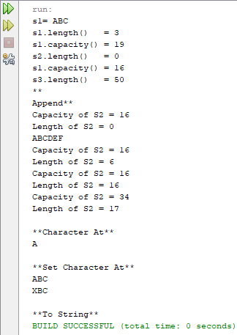

LAB TASK

1.Write a java program to compare any two strings lexicographically and to get the character at the 3 and 4 index within the String.
Sample Output:
String 1: This is Exercise 1
String 2: This is Exercise 2
"This is Exercise 1" is less than "This is Exercise 2"
The character at position 0 is T
The character at position 4 is s

2. Write a Java program to convert all the characters in a string to lowercase.
Sample Output:
Original String: The Quick BroWn FoX!
String in lowercase: the quick brown fox!

3. A PALINDROME is a word which has SAME SPELLING whether it is read from Left to Right or from Right to Left. Example: MOM, DAD, DEED, PEEP and NOON. Other words which are not PALINDROME are HELLO, DOOR and FEET. Write a program that can read a String as user input in Capital Letters and then Print YES as Output if the Input is a PALINDROME otherwise NO.

4.Write a program that extracts username & domain information from Email address.
Example:
if the email address is "user@my.com", your program will print
User name = user
Domain = my
Extension = com

